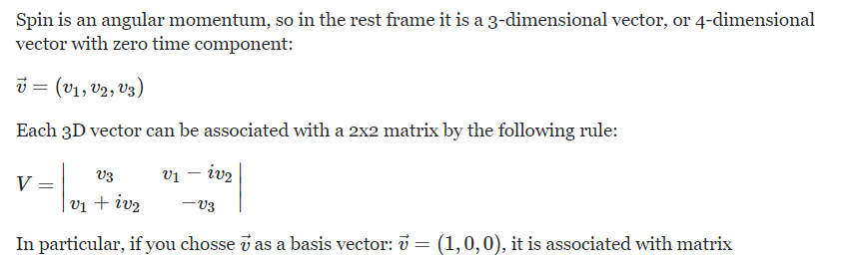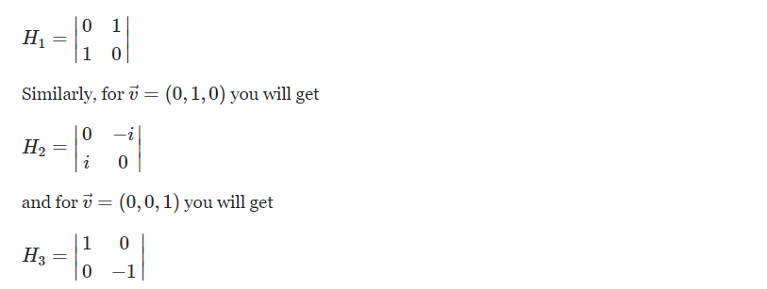

Where do they get this V vector from. Why is this a general definition for a 3D-vector?
Question is in red
The text is taken from here:
https://physics.stackexchange.com/questions/20201/how-are-the-pauli-matrices-for-the-electron-spin-derived

